**Covid 19 Data analysis :**

**Task1:**

1. **Load the covid 19 data in to a spark dataframe**

**(country_wise_latest.csv) with the correct schema definition**

[mavricbdhoct07@ip-10-1-1-204 ~]$ hdfs dfs -put country_wise_latest.csv

[mavricbdhoct07@ip-10-1-1-204 ~]$ hdfs dfs -ls

**>>>covidDF=spark.read.option("header",True).option("inferSchema",True)**

**.csv("country_wise_latest.csv”)**

**>>>covidDF.printSchema()**

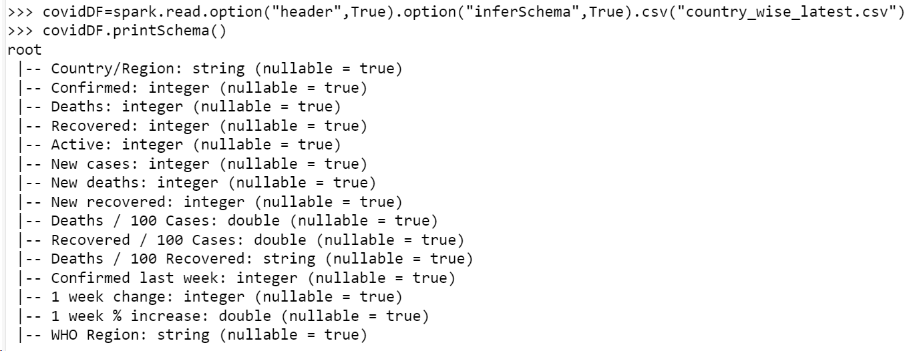

**>>>covidDF.show()**

**>>>covidDF.createOrReplaceTempView("covid")**

1. **The are some column names which are long, contains specia**

**characters, spaces etc. Rename all such column names accordingly. Example Country/Region → country New cases → New_cases etc**

covidDF.withColumnRenamed("Deathsper100 Recovered","Deathsper100_Recovered").show(truncate=False)

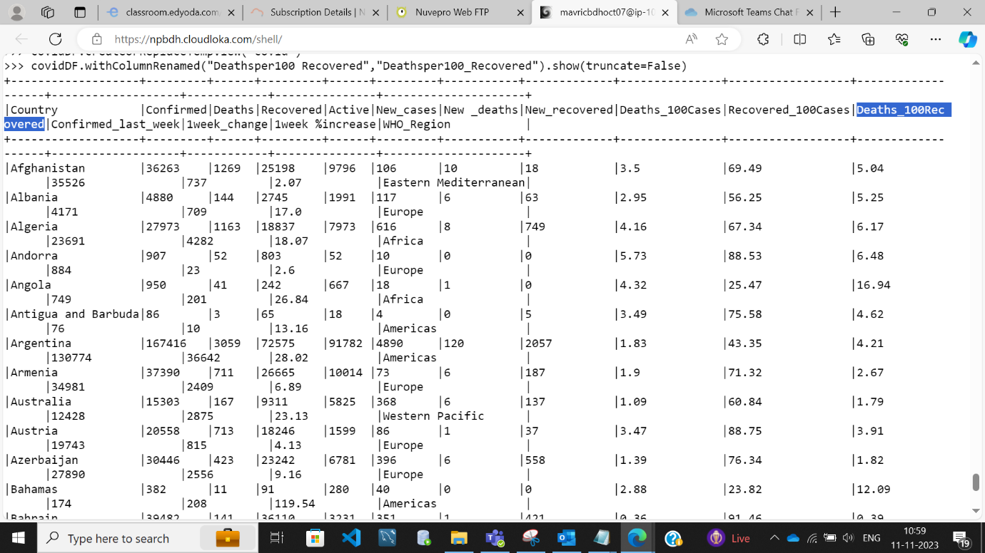

**3 . Count and check if there any null values in any of the columns**

**import pyspark.sql.functions as F**

**covidDF_agg = covidDF.agg(*[F.count(F.when(F.isnull(c), c)).alias(c) for c in covidDF.columns])**

**covidDF_agg.show()**

**4. What are the top 10 countries under the WHO region with covid 19**

**Confirmed cases**

spark.sql( "SELECT Country,WHO_Region,Confirmed FROM covid").show()

spark.sql( "SELECT Country,WHO_Region,sum(Confirmed) FROM covid GROUP BY Country, WHO_Region order by 3 desc").show(10)

**5. What are the bottom 10 countries under the WHO region with covid 19**

**Confirmed cases**

spark.sql( "SELECT Country,WHO_Region,Confirmed FROM covid").show()

spark.sql( "SELECT Country,WHO_Region,sum(Confirmed) FROM covid GROUP BY Country, WHO_Region order by 3 asc").show(10)

**6. What are the total number of countries/ total no. of WHO regions and also list the various WHO regions**

spark.sql("SELECT count(distinct Country), count(distinct WHO_Region) from covid").show()

spark.sql("SELECT distinct WHO_Region from covid").show()

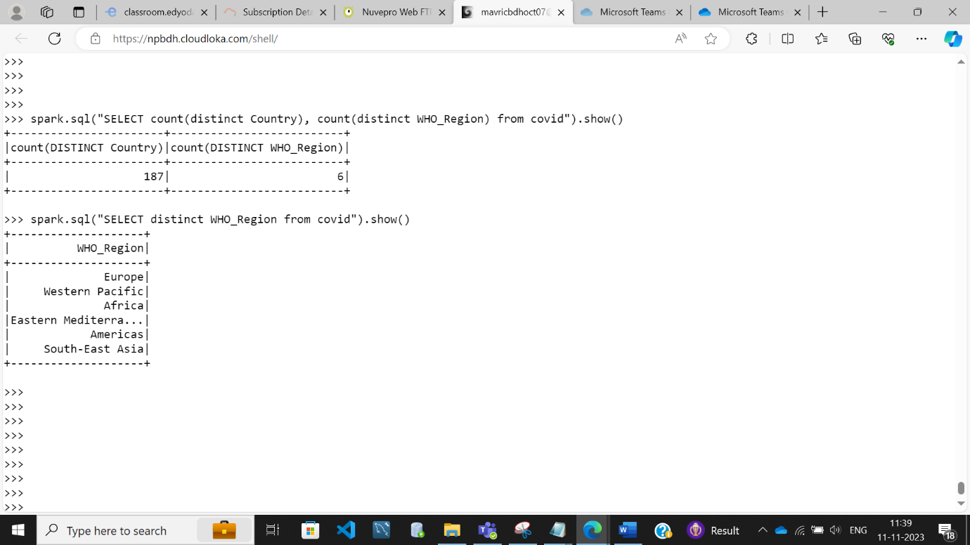

**spark.sql("SELECT count(distinct Country), count(distinct WHO_Region),WHO_Region from covid group by WHO_Region").show()**

